Business Requirements Document (BRD)

**Project Title:** Cost Estimation for Home Renovation and Construction

# Project Overview:

Homeowners and contractors often face challenges in estimating the accurate costs of home renovations, interior design projects, and new constructions. These challenges often lead to miscalculations, budget overruns, and project delays. This project aims to develop a cost estimation solution that allows users to input project specifications and receive detailed, accurate estimates, including material costs, labour, and design variations.

# Objectives:

The primary objective of this solution is to:

* + Provide an easy-to-use platform where users (homeowners and contractors) can input project details and get an accurate cost estimate.
  + Help users better plan their budgets and timelines by providing detailed breakdowns of costs such as materials, labour, and design variations.
  + Reduce manual errors in cost calculations that lead to budget overruns and delays.
  + Enhance the user experience with features like multiple design options and real- time cost comparisons.

# Stakeholders:

* + **Homeowners:** Homeowners are the primary users of the solution, utilizing it to estimate renovation or construction costs for their homes. They input project specifications, review cost breakdowns, and use the platform to plan budgets and timelines effectively, reducing errors and overspending.
  + **Contractors:** Contractors use the platform to generate accurate estimates for their clients and manage multiple projects. The system helps them provide detailed quotes, compare material and labour costs, and ensure that projects stay within budget and on schedule.
  + **Interior Designers:** Interior designers use the platform to explore different design variations, calculate associated costs, and provide clients with detailed, aesthetically driven project plans. The system helps them adjust designs based on budget constraints and client preferences.

# Functional Requirements:

* + **FR-1:** The platform should have a user-friendly interface to input all relevant project details.
  + **FR-2:** The platform should include a cost estimation engine that uses predefined formulas and real-time data for calculations.
  + **FR-3:** The platform should support different types of projects new constructions, interior design projects and for both also.
  + **FR-4:** The platform should provide an itemized breakdown of costs for materials, labour, and other expenses.
  + **FR-5:** The platform should support integration with third-party services (e.g., material price databases or labour market rates) for real-time pricing data.
  + **FR-6:** The platform should allow for the generation of PDF reports or downloadable summaries for users.

# Non-Functional Requirements:

* + **NFR-1:** The system should handle multiple users simultaneously without performance degradation.
  + **NFR-2:** The system should provide accurate, real-time cost data with less than a 5% margin of error.
  + **NFR-3:** The system should be secure, with strong authentication and data encryption for user information.
  + **NFR-4:** The system should be accessible on both desktop and mobile devices.

### **5. User Stories**

#### **1. As a Homeowner**

* **User Story 1:** As a homeowner, I want to input my project details (such as project type, dimensions, and location) so that I can receive an accurate cost estimate.
* **User Story 2:** As a homeowner, I want to compare multiple design variations with cost implications, so I can choose a design that fits my budget and style preferences.
* **User Story 3:** As a homeowner, I want to download a detailed report of my project cost estimate, including a breakdown of materials and labor, so that I can review it with contractors and make informed decisions.

#### **2. As a Contractor**

* **User Story 1:** As a contractor, I want to generate cost estimates based on the latest material and labor prices, so I can provide accurate quotes to clients and avoid budget overruns.
* **User Story 2:** As a contractor, I want to adjust project details or material choices within the platform, so I can quickly offer alternative options to clients based on their budget constraints.
* **User Story 3:** As a contractor, I want to receive notifications about changes in material or labor costs, so I can update clients proactively and adjust project estimates accordingly.

#### **3. As an Interior Designer**

* **User Story 1:** As an interior designer, I want to explore different design options and see their cost breakdowns, so I can present various aesthetic and budget choices to clients.
* **User Story 2:** As an interior designer, I want to save and organize project variations with cost estimates, so I can quickly switch between design options based on client feedback.
* **User Story 3:** As an interior designer, I want to generate visual and financial reports of design variations, so clients can make decisions based on both cost and design preferences.



**6.Project Architecture**

project follows a **three-tier architecture** with a microservices approach. The primary components are the **Presentation Layer (Frontend)**, **Business Logic Layer (Backend)**, and **Data Layer (Database)**. The system and microservices will be registered via **Eureka servers** for service discovery and load balancing.

# 6.1 Presentation Layer (Frontend)

* + - **Framework**: React with TypeScript
    - **State Management**: Redux
    - **Libraries**: Material-UI or Bootstrap for UI components
    - **Communication**: RESTful APIs via HTTP to interact with backend services

o This layer will handle user interaction for contractors, homeowners, and designers, allowing them to manage projects, access cost estimates, input project data, and view real-time information.

# Business Logic Layer (Backend)

* + 1. **Framework**: Node.js with TypeScript (strictly)
    2. **Microservices Architecture**: Each microservice handles a distinct business function such as:
       1. **Cost Estimation Service**: Calculates project costs based on materials and labour
       2. **Project Management Service**: Manages the lifecycle of projects (start, in-progress, completed)
       3. **Notification Service**: Sends project updates, notifications, post the requirment,alerts via Kafka
    3. **Eureka Server**: For service discovery and load balancing of microservices

# Data Layer (Database)

* + 1. **Database**: MongoDB (Non-relational, scalable) to store:
       1. **User Information**: Profiles of homeowners, contractors, and designers
       2. **Project Data**: Details of ongoing and completed projects
       3. **Material and Labour Prices**: Data for real-time cost estimation
       4. **Estimation History**: Records of previous project estimations
    2. **Caching**: Optional Redis or in-memory database for faster data retrieval (e.g., frequently requested estimates).

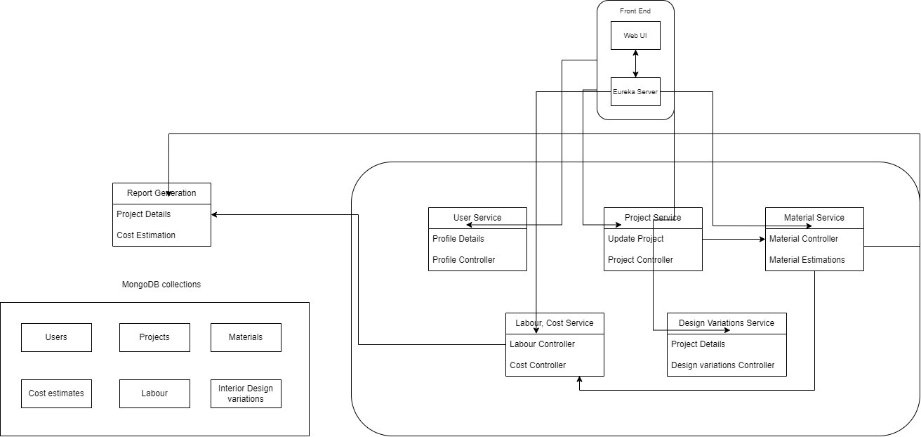

## **7.Authentication Endpoints**

### **User Registration**

* **Endpoint:** POST /api/users/register  
  **Desc:** Register a new user.

### **User Login**

* **Endpoint:** POST /api/users/login  
  **Desc:** Authenticate user and return JWT token.

### **Get Current User Profile**

* **Endpoint:** GET /api/users/me  
  **Desc:** Get the current user profile (requires JWT).

### **Update User Profile**

* **Endpoint:** PUT /api/users/me  
  **Desc:** Update user profile (requires JWT).

### **User Logout**

* **Endpoint:** POST /api/users/logout  
  **Desc:** Log out the current user (optional, based on session strategy).

## **Construction Cost Estimation Endpoints**

### **Add a New Project**

* **Endpoint:** POST /api/projects  
  **Desc:** Add a new construction project (requires user authentication).

### **Get Detailed Project Information**

* **Endpoint:** GET /api/projects/:projectId  
  **Desc:** Get detailed project information by its ID.

### **Update Project Details**

* **Endpoint:** PUT /api/projects/:projectId  
  **Desc:** Update project details (requires authentication).

### **Remove a Project**

* **Endpoint:** DELETE /api/projects/:projectId  
  **Desc:** Remove a project from the system (requires authentication).

## **Cost Estimation Endpoints**

### **Estimate Project Cost**

* **Endpoint:** POST /api/cost-estimates  
  **Desc:** Estimate the cost of a project based on parameters (requires user authentication).

### **Get Cost Analysis Report**

* **Endpoint:** GET /api/cost-estimates/report/:projectId  
  **Desc:** Get a detailed cost analysis report for a specific project.

## **Analytical Reports and Visualizations**

### **Get Analytical Dashboard**

* **Endpoint:** GET /api/dashboard  
  **Desc:** Retrieve analytical data and visualizations.

### **Download Cost Estimate Report**

* **Endpoint:** GET /api/reports/download/:projectId  
  **Desc:** Download the cost estimate report for a specific project.

### **Share Cost Estimate Report**

* **Endpoint:** POST /api/reports/share  
  **Desc:** Share the cost estimate report via email.

**8.Database Schema**

**User Table**

* + - **Key :** user_id

# Relationships:

* + - * One-to-Many with the Project Table (a user can have multiple projects).

# Project Table

* + - **Key :** project_id
    - **Ref :** user_id (references User Table)

# Relationships:

* + - * One-to-Many with the Cost Estimate Table (a project can have multiple cost estimates).
      * One-to-Many with the Design Variation Table (a project can have multiple design variations).

# Material Table

* + - **Key :** material_id

# Relationships:

* + - * One-to-Many with the Cost Estimate Table (each estimate can include multiple materials).
      * Many-to-One with the Supplier Table (materials are provided by suppliers).

# Labour Table

* + - **Key :** labour_id

# Relationships:

* + - * One-to-Many with the Cost Estimate Table (each estimate can include multiple labour costs).

# Cost Estimate Table

* + - **Key :** estimate_id
    - **Ref :** project_id (references Project Table)

# Relationships:

* + - * Many-to-One with both Material and Labour Tables.

# Design Variation Table

* + - **Key :** design_id
    - **Ref :** project_id (references Project Table)

# Schema Diagram:

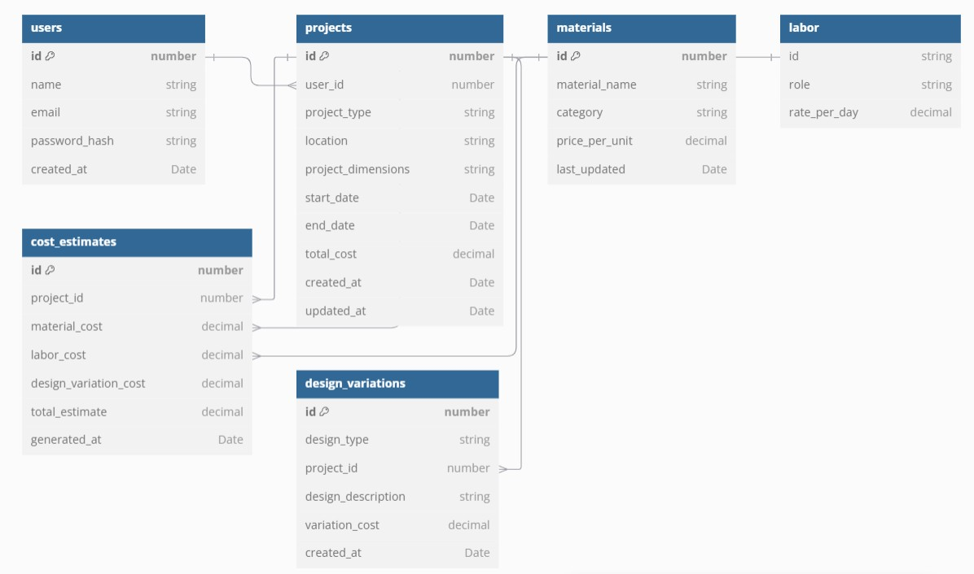

**UML Diagram:**

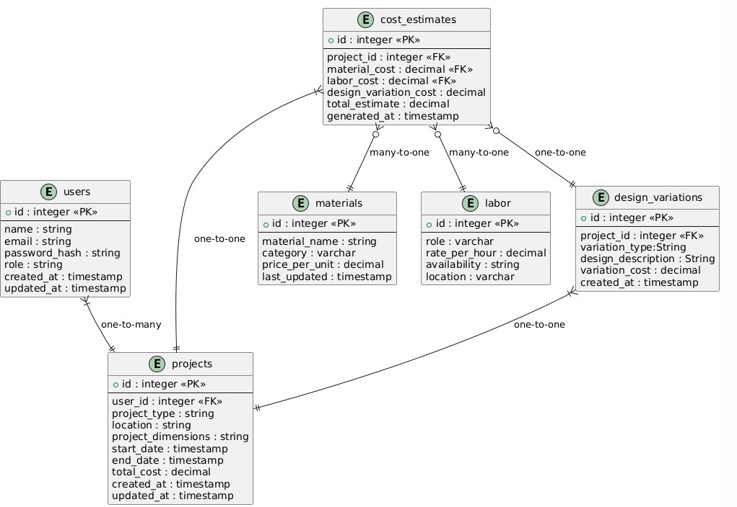

# 9.Workflow

1. **User Actions:**
   * Register/Login → Create Project → Input Project Details → View Estimate → Compare Estimates (optional) → Generate Report

# Backend Processing:

* + Input Validation → Data Aggregation (External APIs) → Cost Calculation (Estimation Engine) → Store Estimate in Database → Report Generation

# System Notifications:

* + Send notifications about changes in project estimates due to material or labour price updates.